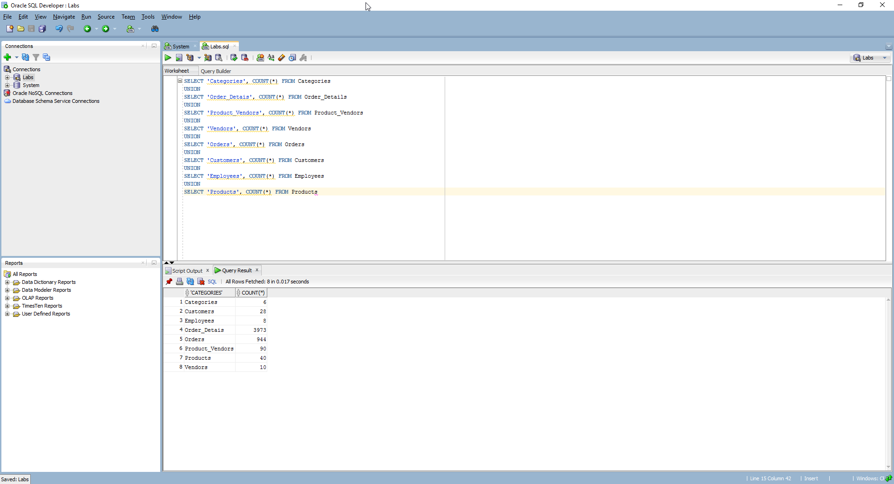

Q&A

1. Composite key
2. Foreign key
3. Query
4. Junction table